

AADHAAR AUTHENTICATION ECOSYSTEM PROJECT, DEPARTMENT OF INFORMATION TECHNOLOGY & COMMUNICATION, GOR

December 21, 2023

User Manual for Raj-UPASTHITI APPLICATION (COLLEGE EDUCATION MODULE)

Contents

1. Raj Attendance: 2

2. Super Admin User: 2

2.1. Department Admin Registration 3

3. Department Admin 5

3.1. College Master Creation 5

3.1.1. College List Upload 6

3.1.2. College Registration 7

3.2. College Admin Registration 8

3.3. Course creation 10

3.4. Attendance Report 13

4. College Admin 14

4.1. Student Registration 14

4.2. College Holidays Creation 17

4.3. Attendance Report 18

5. Student 19

5.1. Student Attendance Report 20

1. Raj Attendance: Raj Upasthiti application provides an Aadhaar enabled platform to government employees/College Students to mark attendance. Attendance system enables an employee/College Students to register attendance by simply scanning the Face using smartphone camera. This event is authenticated online after one-to-one match with the Face biometric attributes stored in the UIDAI database against the employee/College Students’ Aadhaar number. This system provide facility to departments/colleges for on-boarding, employee/student registration and attendance report at centralize location.

**Type of users in the System: -**

* **College Education Module: -**
* **Department Admin (Education)**
* **College Admin**
* **Student**
* **Employee Module: -**
* **Department Admin**
* **Office Admin**
* **Employee**

1. Super Admin User: Super Admin user will be in the Raj-Upasthiti application who is responsible for management of Department Admin (Education) and Department Admin user.

* **Dashboard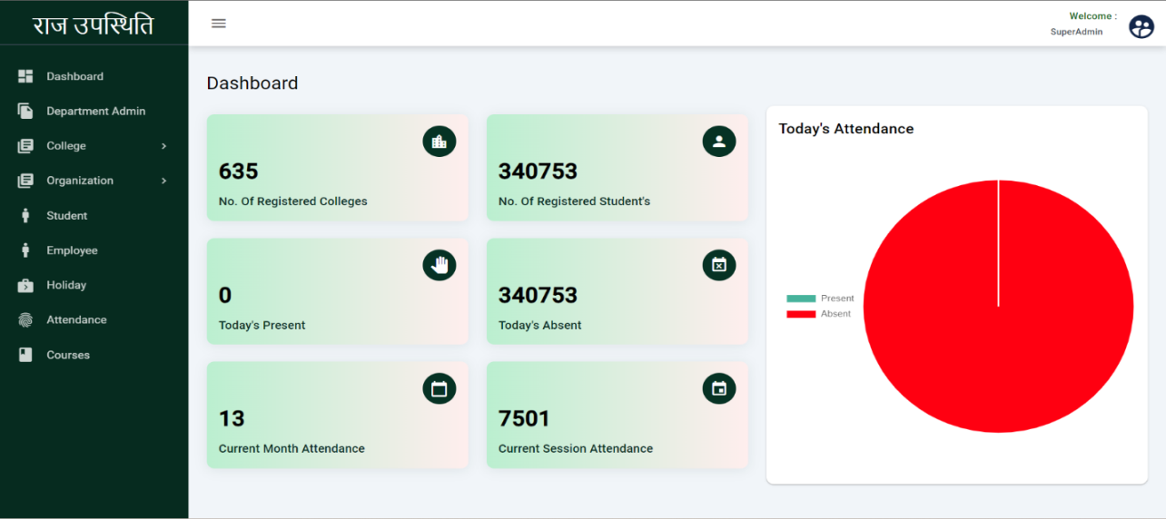:** Student Dashboard shows the No. of registered colleges, No. of registered students, Current month attendance, Current Session Attendance, etc. Employee Dashboard shows data related to employee attendance.

## Department Admin Registration

On this page Super admin can view the registered department admins. Super admin can register the department admin from here. Super admin can also enable and disable the department admin user.

Click here to register the department admin

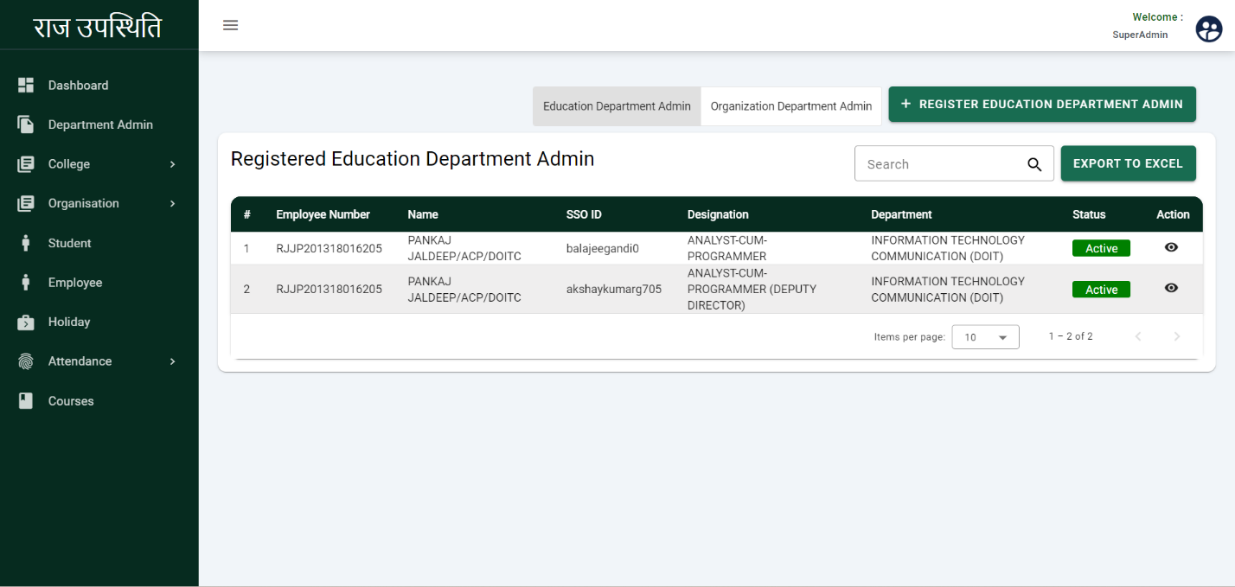

Click here to active and in active the user

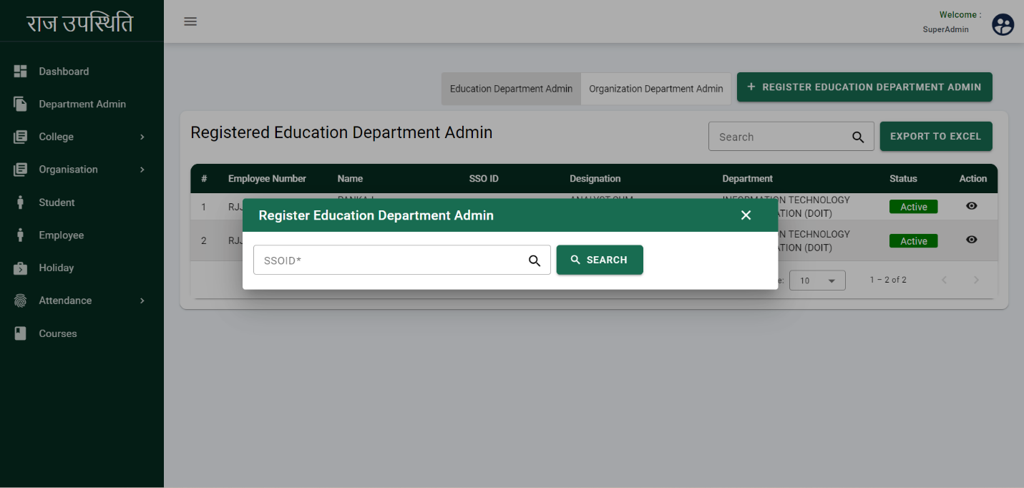

* Enter SSO ID of Department Admin

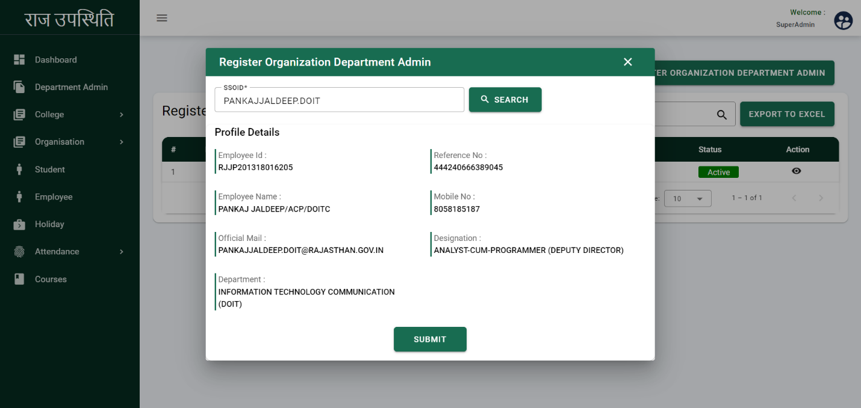

* After enter the SSO ID it will fetch the employee details
* Click On the Submit

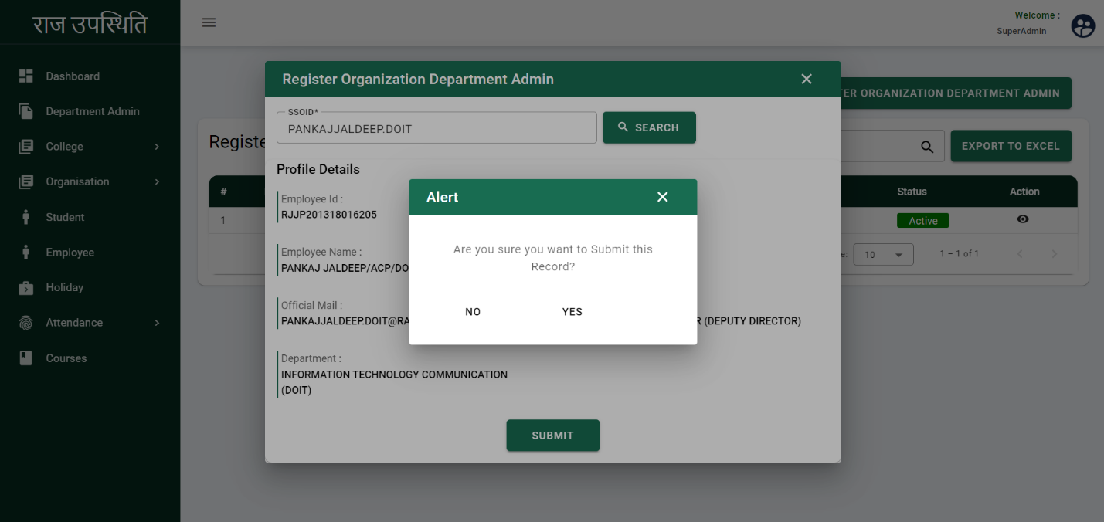

* After Submit the application Alert Pop up will show.
* Click on the YES

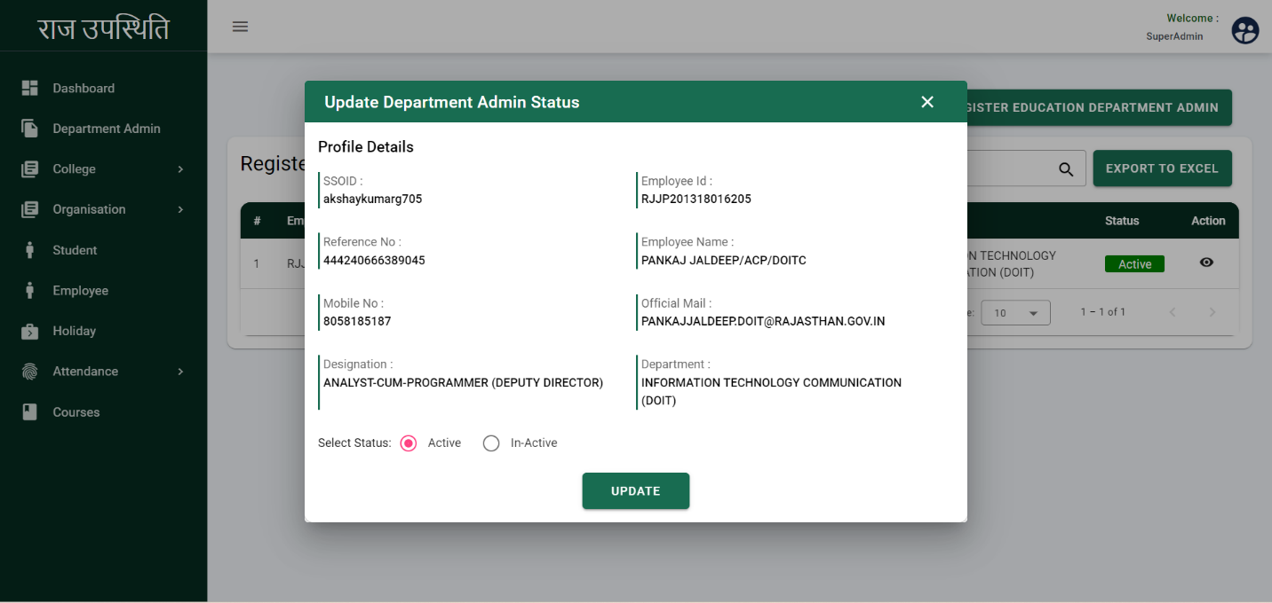

* After Click on the action button this pop up will display.
* Select the Status Active or In-Active
* Click on the UPDATE

# Department Admin

## College Master Creation

Department admin can view the college master including the College name and Registration No. Department admin can create and edit the college master.

Click here to create the college

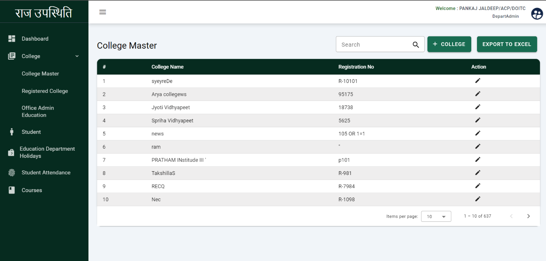

### College List Upload

Department admin will be able to create the college with the following details

* 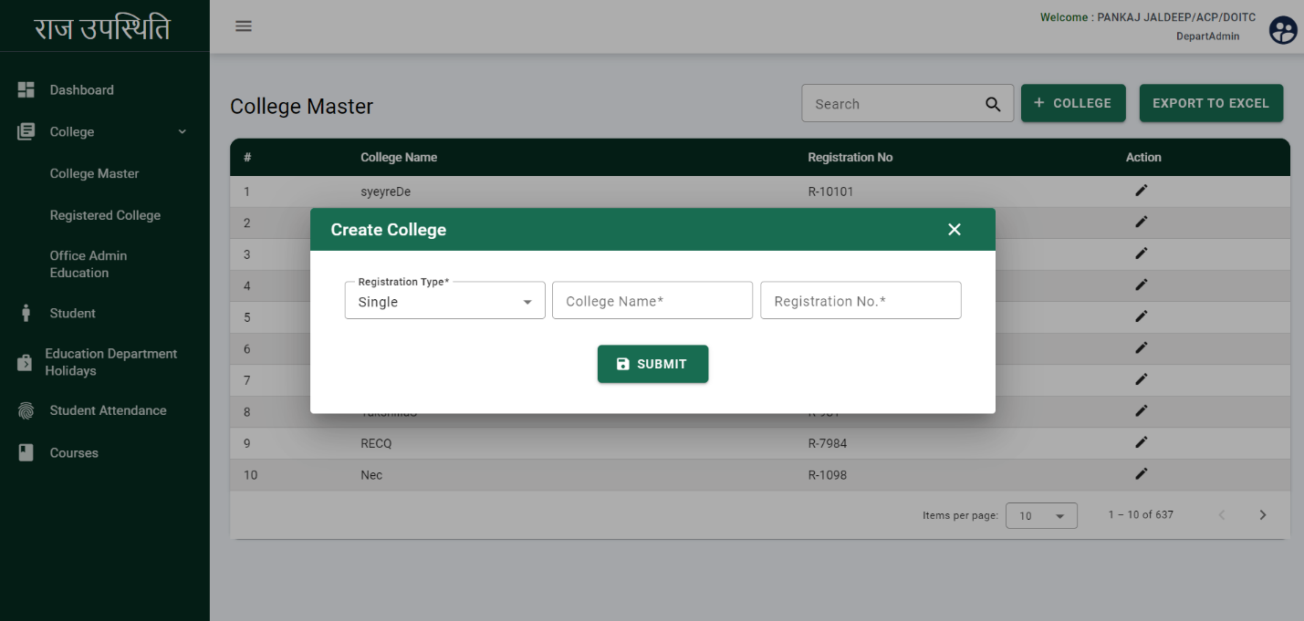Select the registration type i.e. Single or bulk
* Select the single.
* Enter the College Name
* Enter the Registration No.
* Click on the Submit

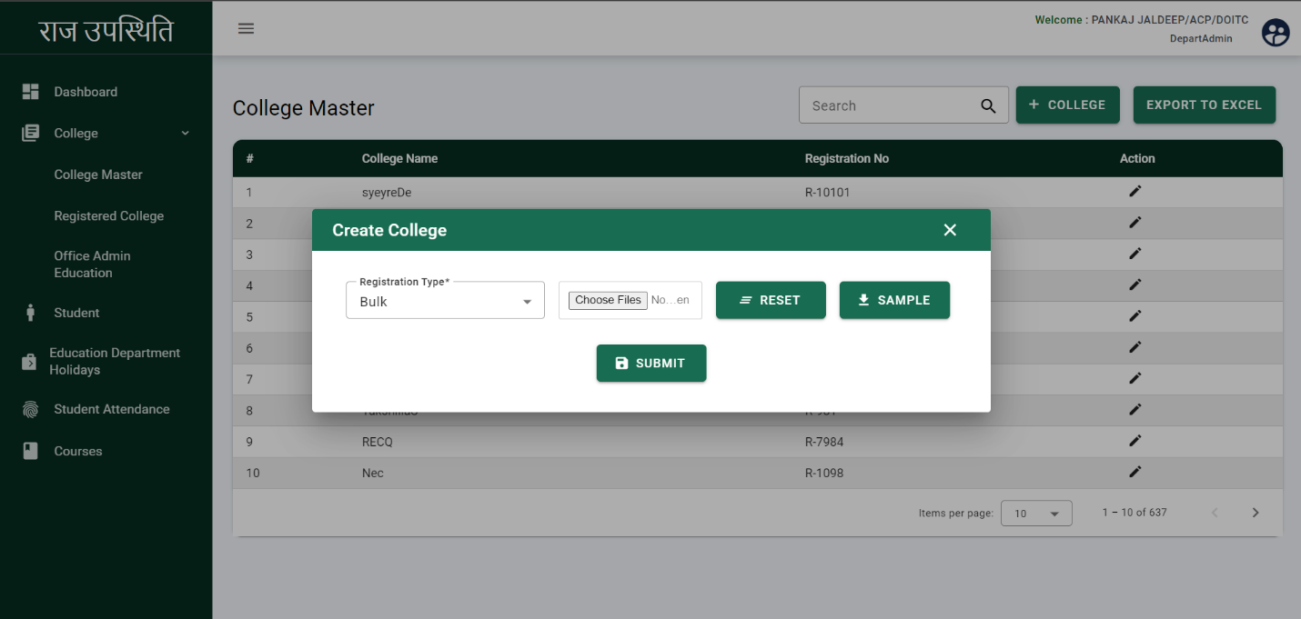

* Department admin can create the college in bulk.
* Select the bulk.
* Choose the files of the colleges.
* Click on the SUBMIT

### College Registration

Department admin will be able to view the registered colleges including college name, Address, District, and Registration No. Latitude, Longitude, In time, out time. Department Admin can Register and edit the college.

Click here to edit the registered college details

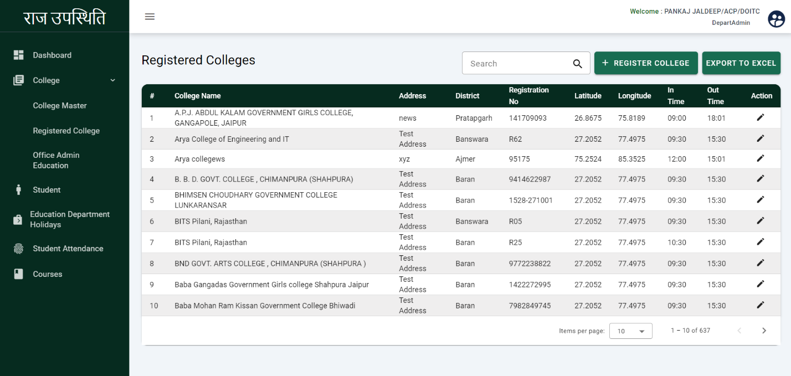

* **Register College:** Department admin will register the college with the following details

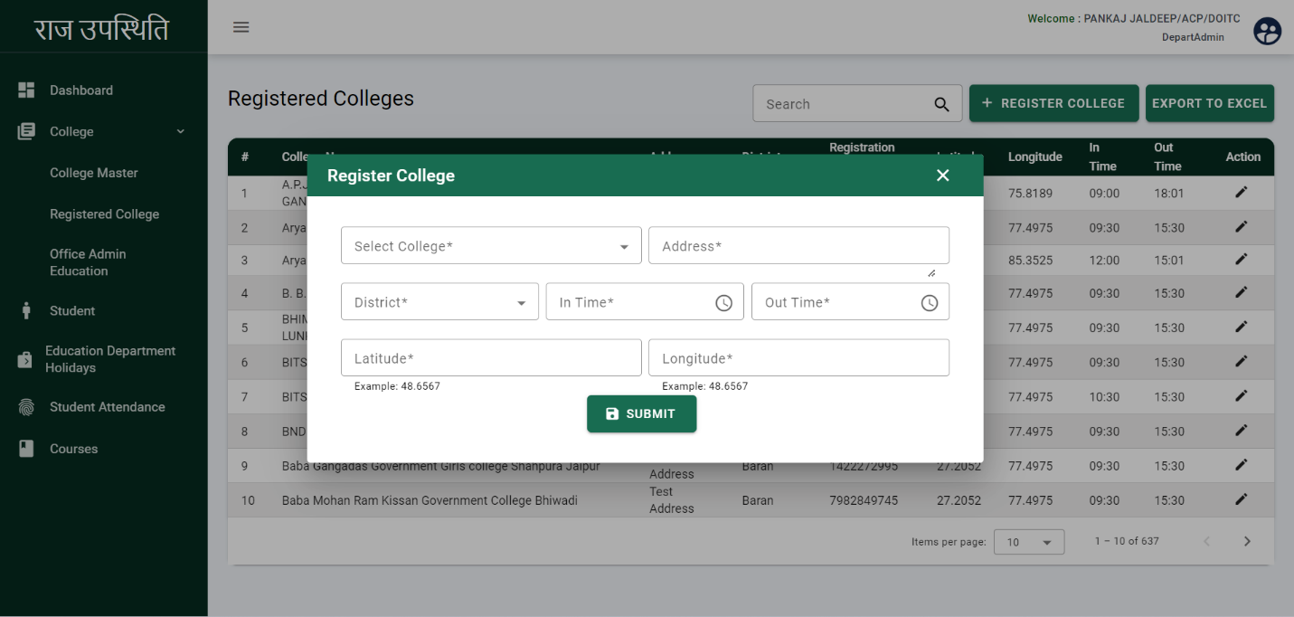

* Select the college from the dropdown.
* Enter the address.
* Select the district.
* Enter the In time
* Enter the Out time
* Enter the latitude and longitude.
* Click on the SUBMIT

## College Admin Registration

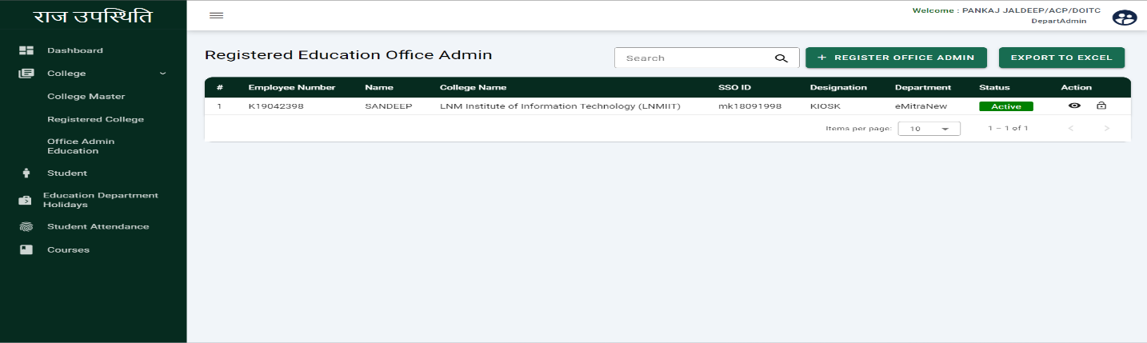Department admin will be able to view the registered college admin including Employee number, Name, College Name, SSO ID, Designation, Department, and Status.

Click here to update the status

* **Register College Admin:** The Department admin will be able the register the college admin with the following details

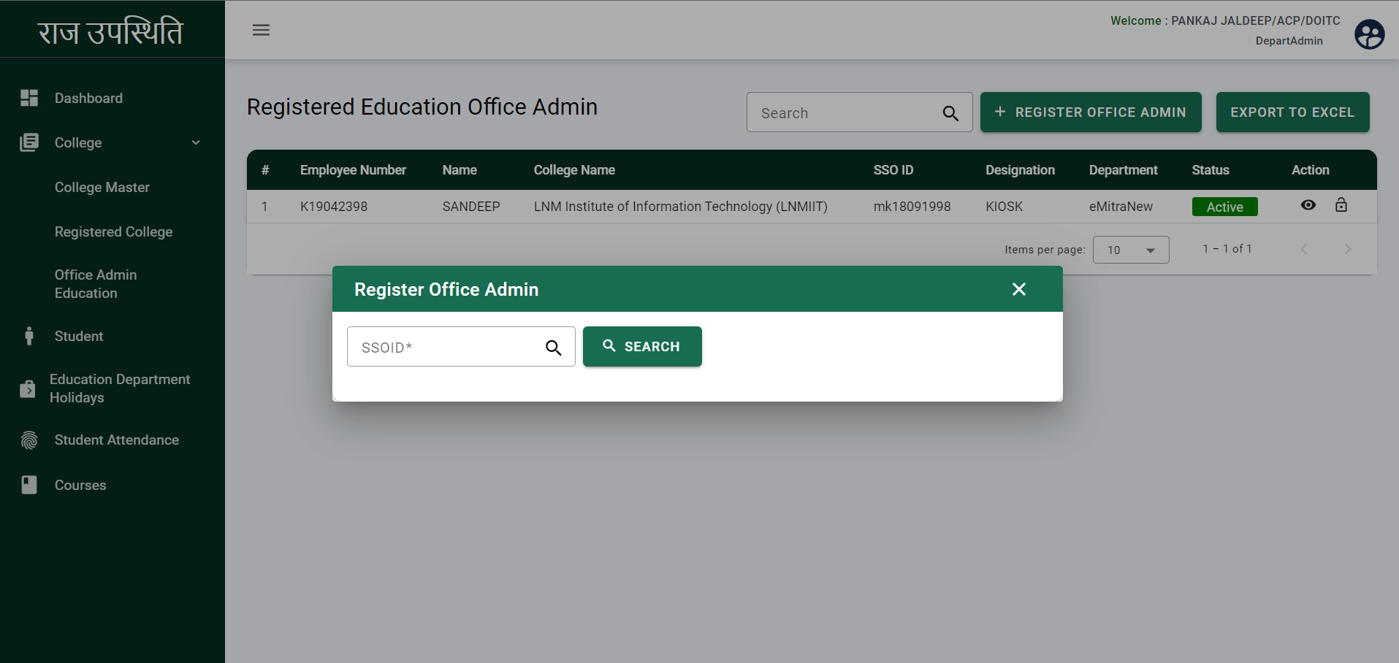

* Enter the SSO ID
* After entering the SSO ID employee details will be fetched

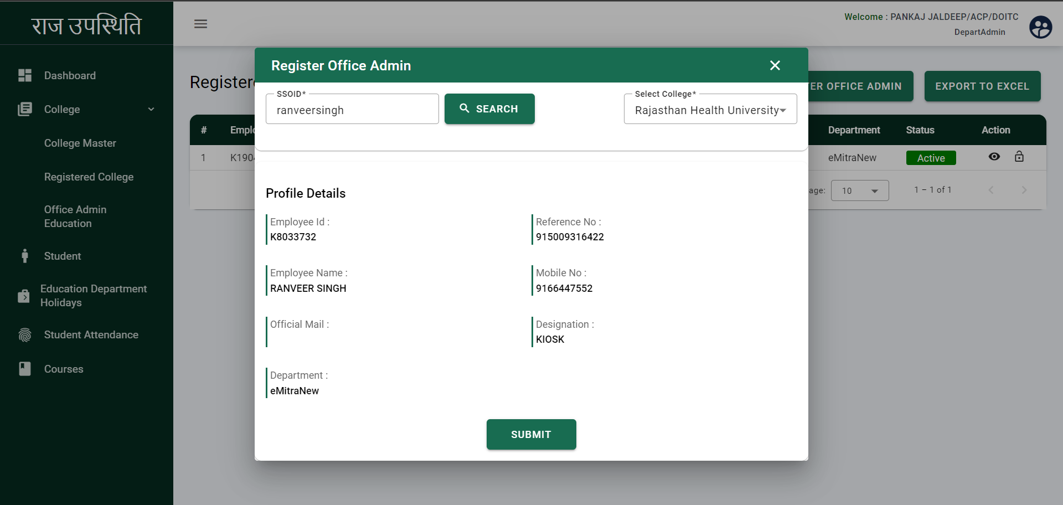

* Select the College from the dropdown.
* Click on the SUBMIT.
* College admin will be registered successfully.

## Course creation

Department admin will be able to view the Course details including Course Name. Department admin can add the Course, Stream, Year, Session, and Common Session. The Department admin can edit and delete the course.

Click here to delete the course

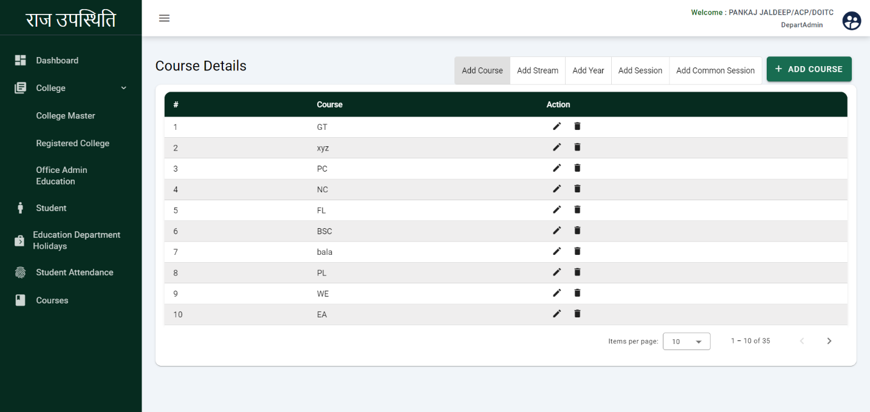

Click here to edit the course details

Click here to Add the course

* **Add Course:** Department admin will add the course with the following details

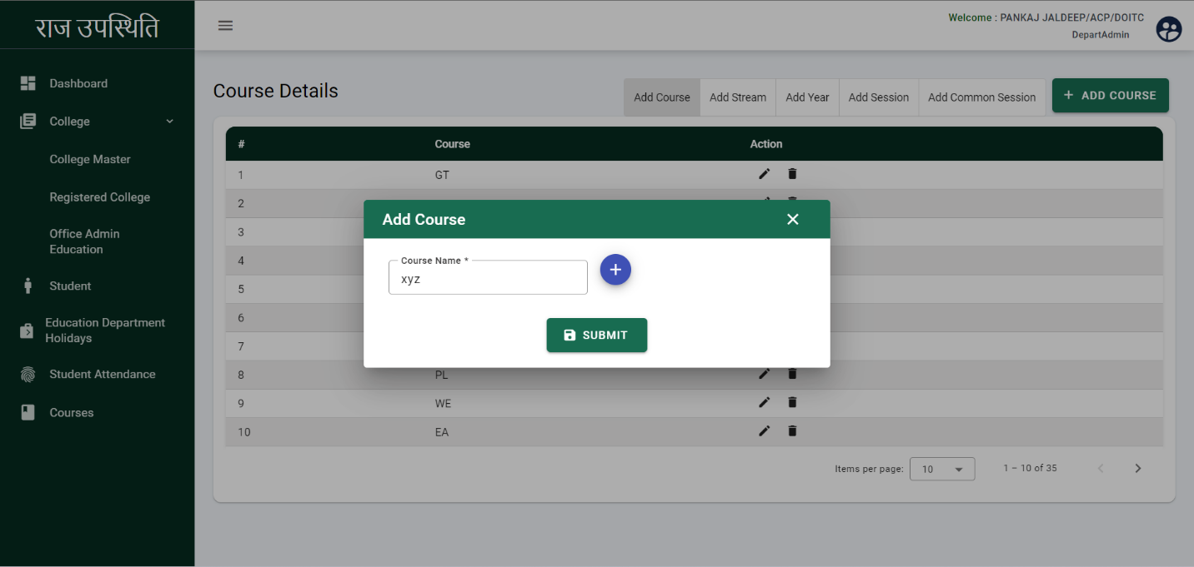

Click here to add multiple course

* Enter the Course Name
* Click on the SUBMIT
* Course will be added successfully.
* **Add Stream:** Department admin will add the Stream with the following details

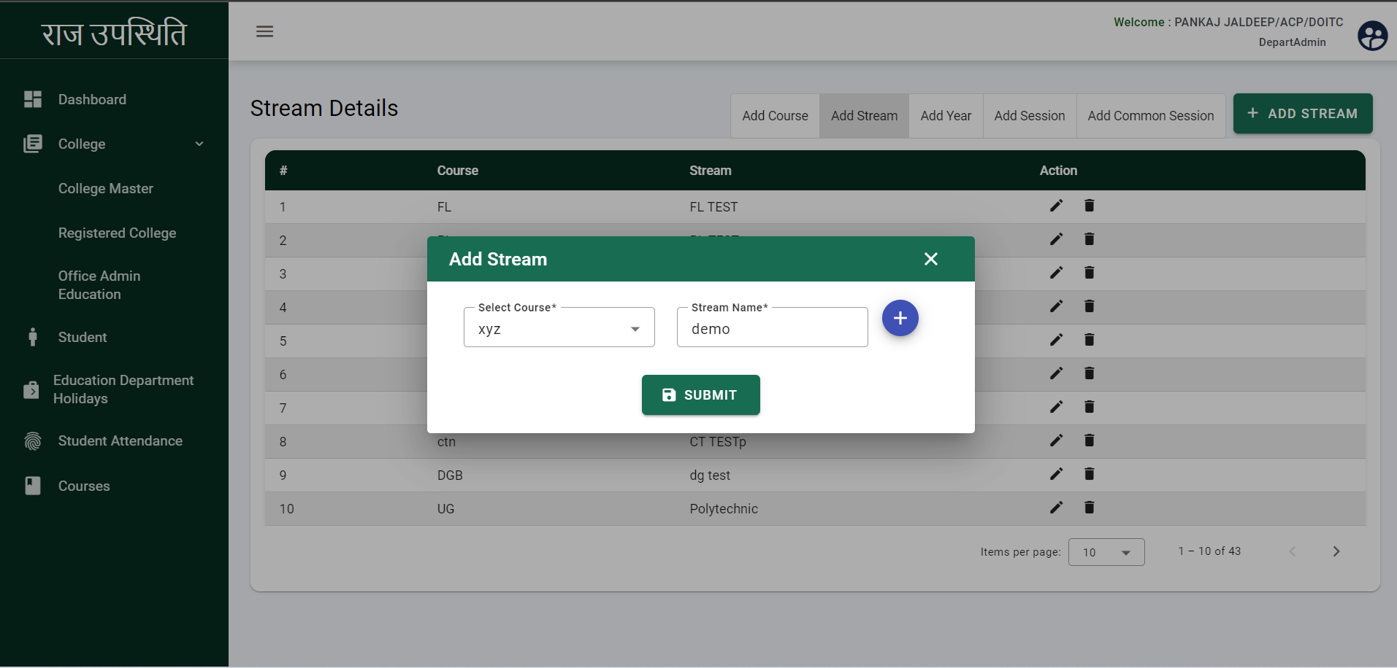

Click here to add multiple stream

* Select the Course from the dropdown.
* Enter the Stream Name
* Click on the SUBMIT
* Stream will be added successfully.
* 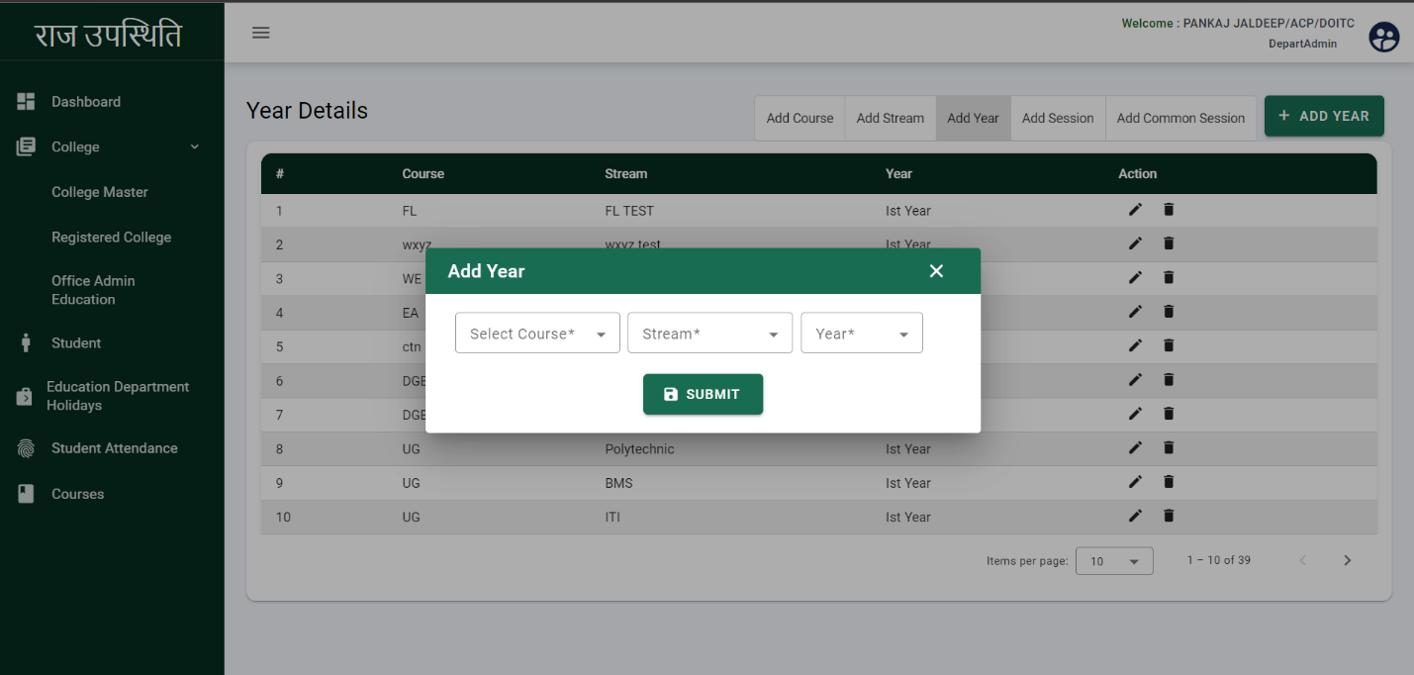**Add Year:** The department admin will be able to add the course year with the following details.
* Select the course
* Select the Stream
* Select the Year
* Click on the SUBMIT
* Year will be added successfully
* **Add Session:** The department admin will add the session with the following details

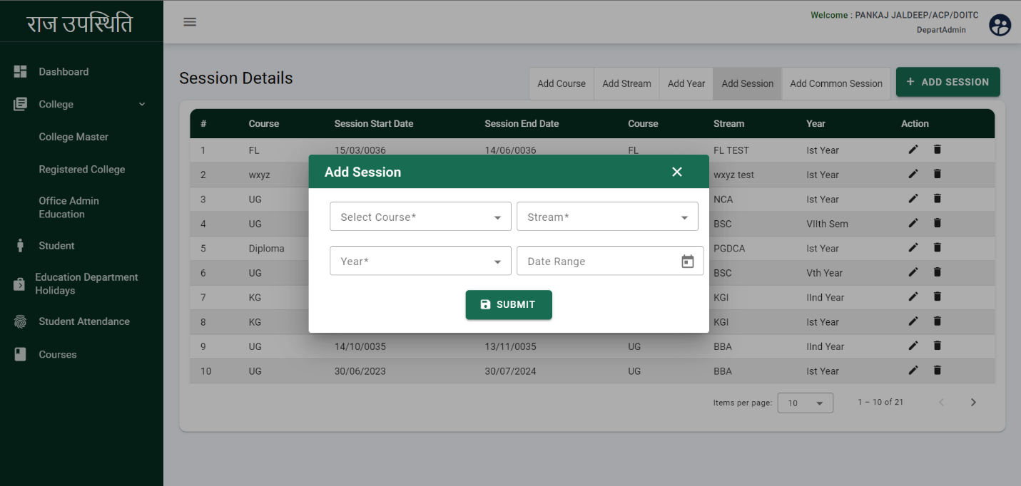

* Select the Course
* Select the Stream
* Select the Year
* Select the date range
* Click on the SUBMIT
* Session will be added successfully.

## Attendance Report

Department admin can view the attendance report of the students including College name, Course, Stream, Year, Date Range, Total Student, Total present, Total Absent.

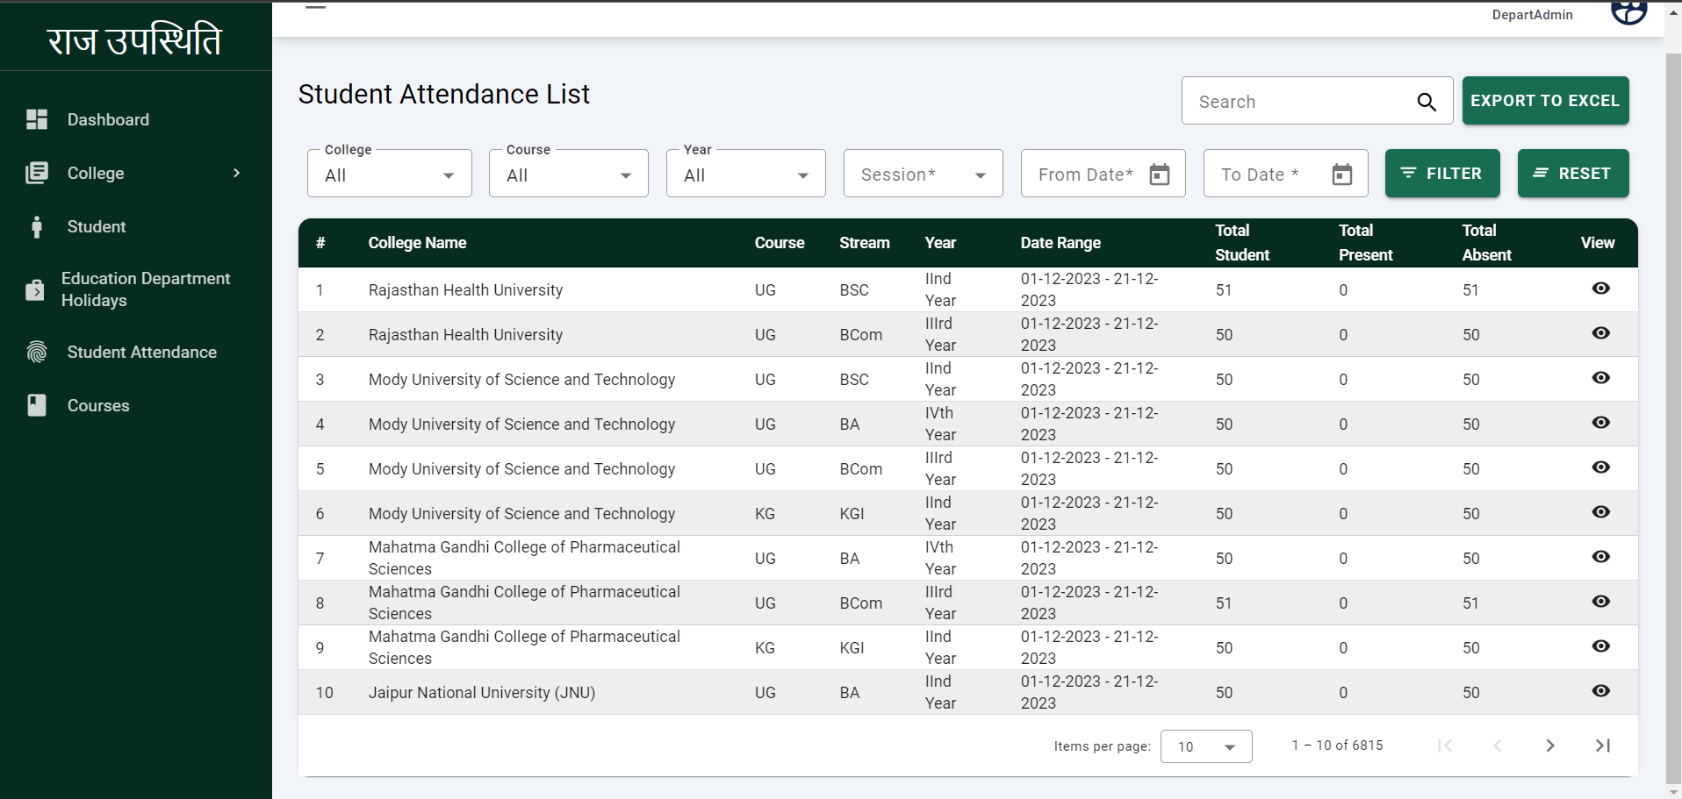

* After click on the student attendance this page will display.
* Department admin can view the attendance of the particular date.
* Click on the view icon to view the attendance.

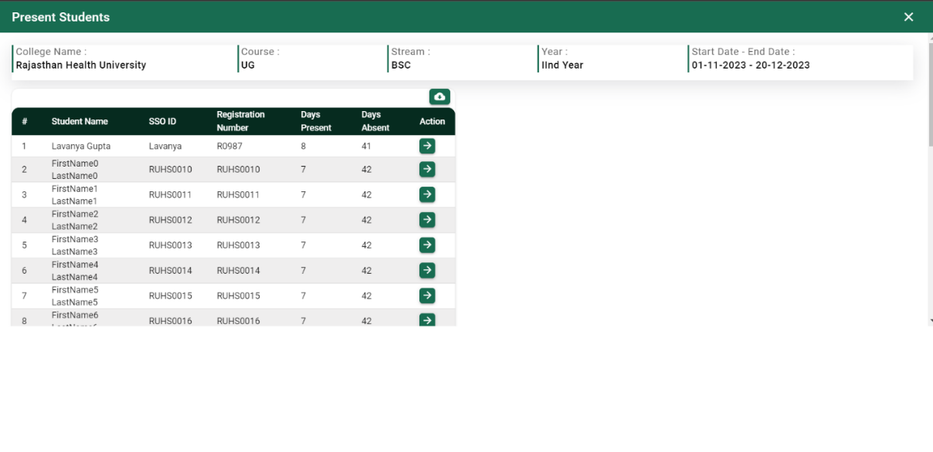

* After click on the view icon this page will display.
* Department admin can export to excel.
* 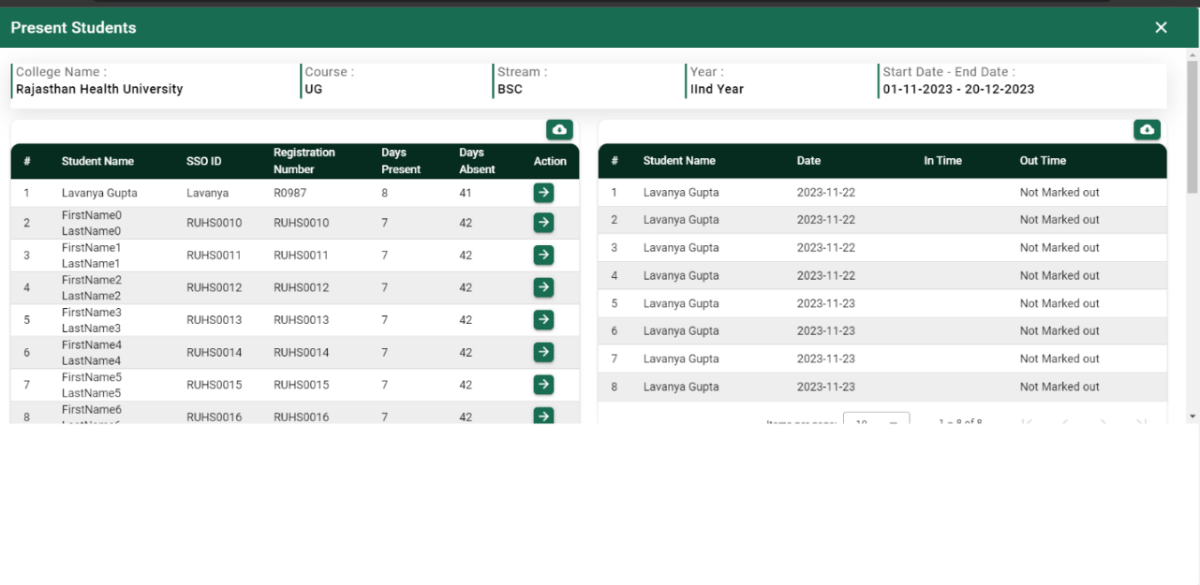Click on the action button to view the present list.

# College Admin

The college admin will have access to the students, Admin can add and edit the student's details.

## Student Registration

College Admin can view the registered student including Student Name, SSO ID, Registration Number, Gender, College Name, Course, Stream, and Year. Admin can add and edit the students.

Click here to edit the student details

.

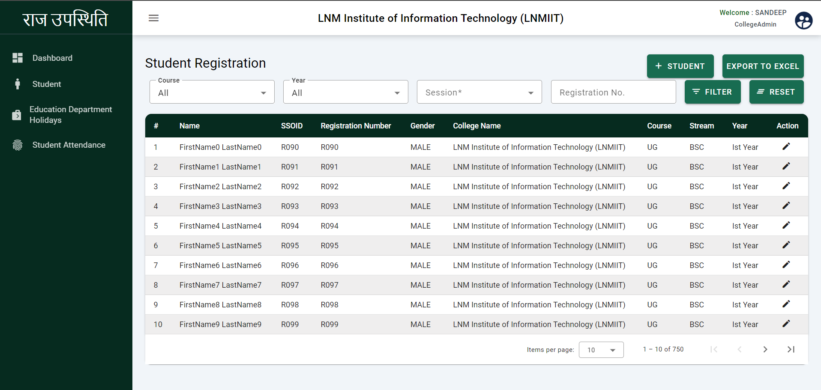

* College admin can use the search filter using College, Course, Year, Session, And Registration Number.
* **Add Student:** College admin can add the student with the following details.

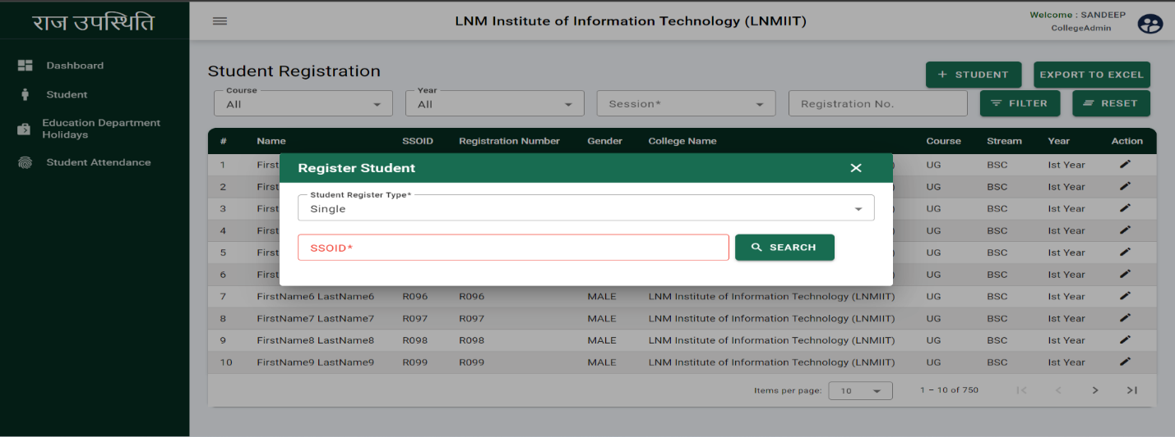

* College admin will select the student register type i.e. Single or bulk.
* Select the single.
* Enter the SSO ID.
* Click on the SEARCH

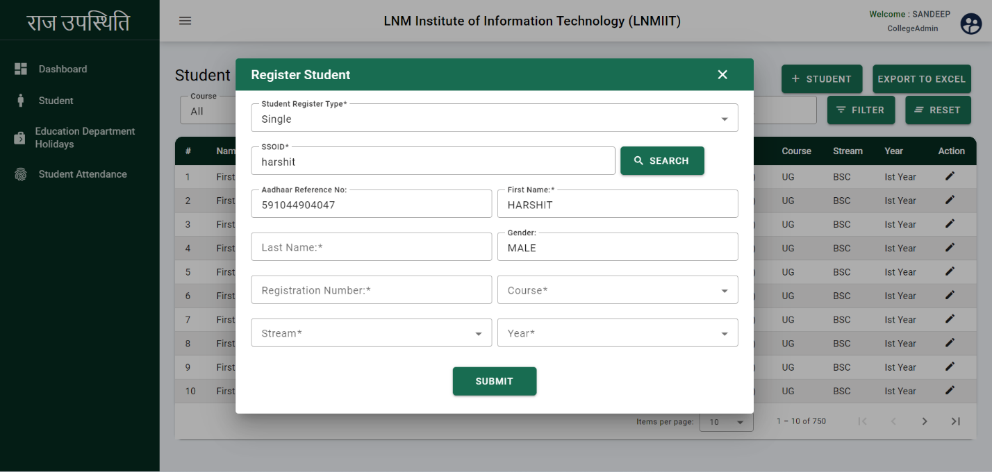

* After clicking on the search this pop-up will display.
* Aadhaar reference No. will show automatically.
* Enter the Last Name.
* Enter the Registration NO.
* Select the Course from the dropdown.
* Select the stream from the dropdown.
* Select the Year.
* Click on the SUBMIT
* 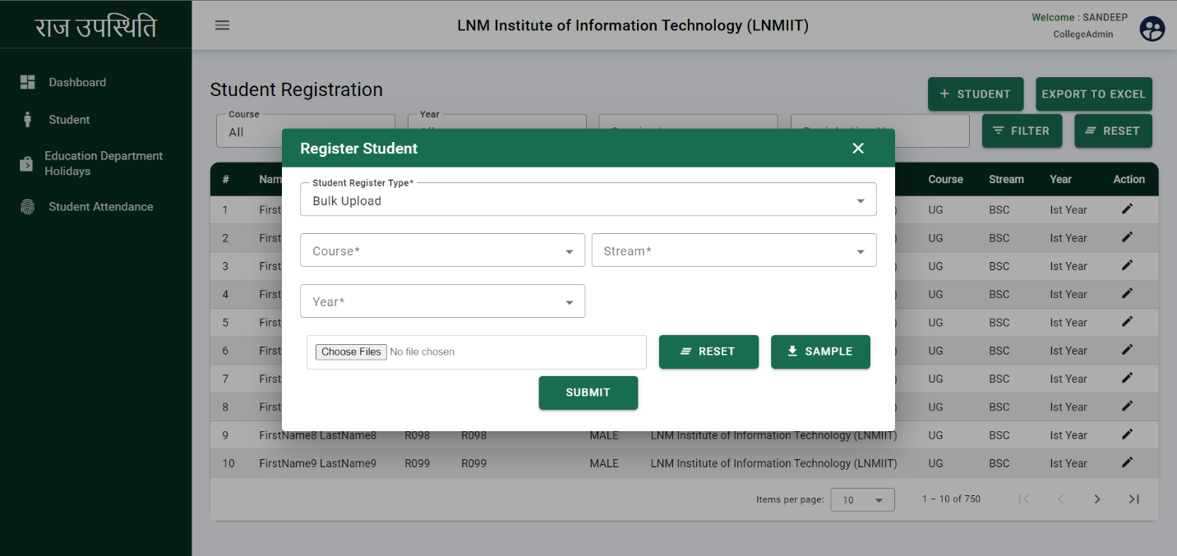Student will register successfully.
* College admin can register students in bulk.
* Select the student register type i.e. Bulk Upload.
* Select the Course.
* Select the Stream.
* Select the Year.
* Download the sample file and fill the Excel file.
* Upload the file from the system.
* Click on the SUBMIT
* Students will register successfully.

## College Holidays creation

College admin can view the education department holidays including, Holiday Date, Holiday Name.

Click here to edit the holiday details

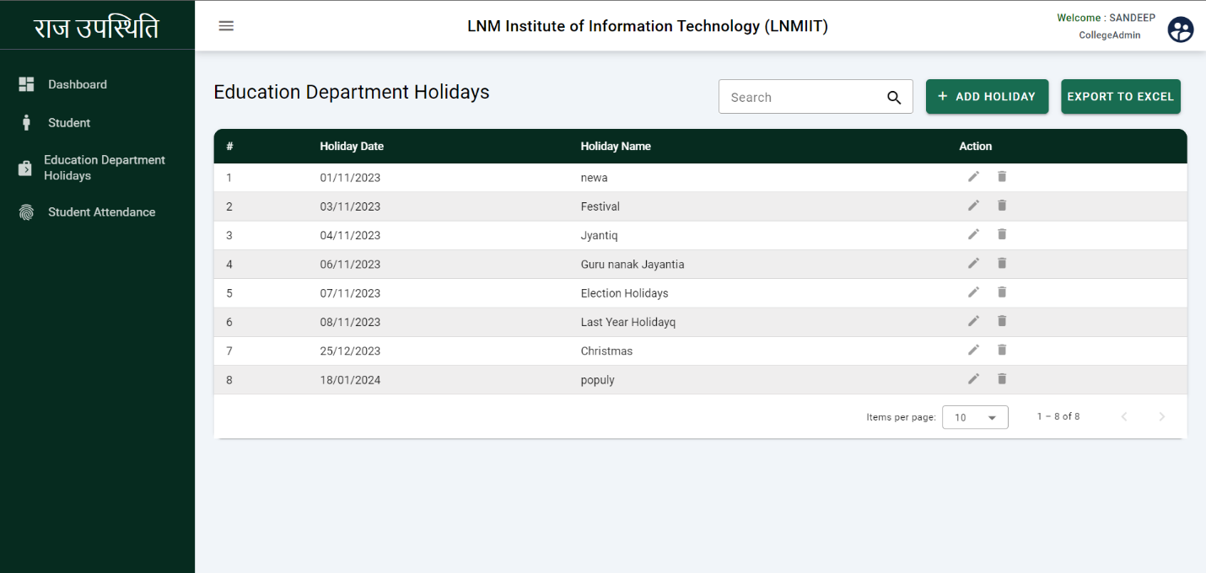

* 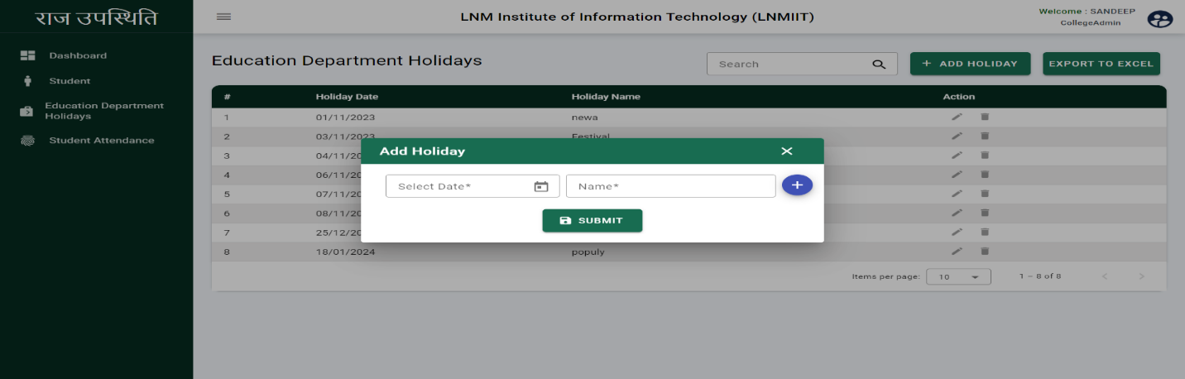**Add Holiday:** College Admin can add the holiday with the following details

Click here to add multiple holidays

* Select the date of the holiday.
* Enter the name of Holiday.
* Click on the SUBMIT
* Holiday will be added successfully.

## Attendance Report

College admin can view the attendance report of the students including, Course, Stream, Year, Date Range, Total Student, Total present, Total Absent.

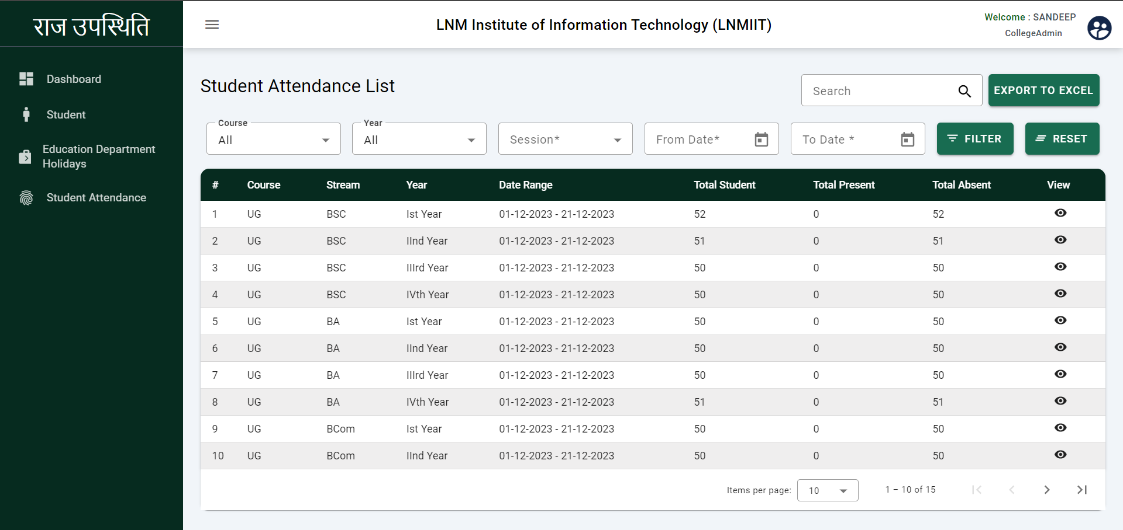

* After click on the student attendance this page will display.
* College admin can view the attendance of the particular date.
* Click on the view icon to view the present student attendance.

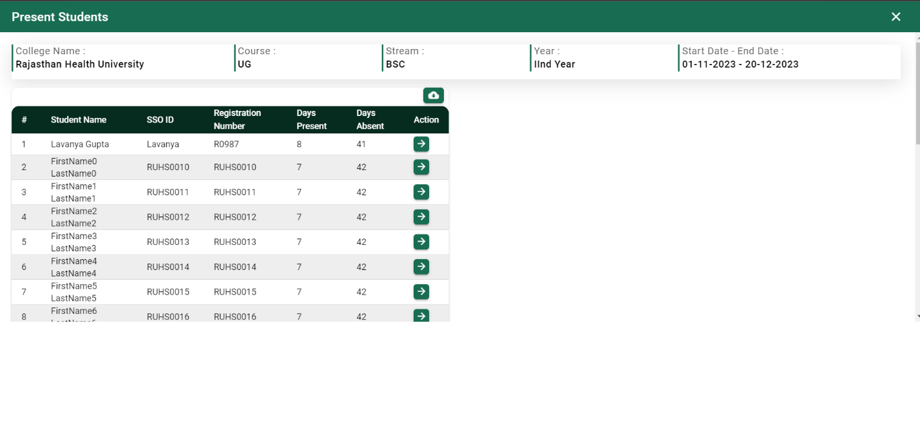

* After click on the view icon this page will display.
* College admin can export the attendance in excel.
* Click on the action button to view the present list.

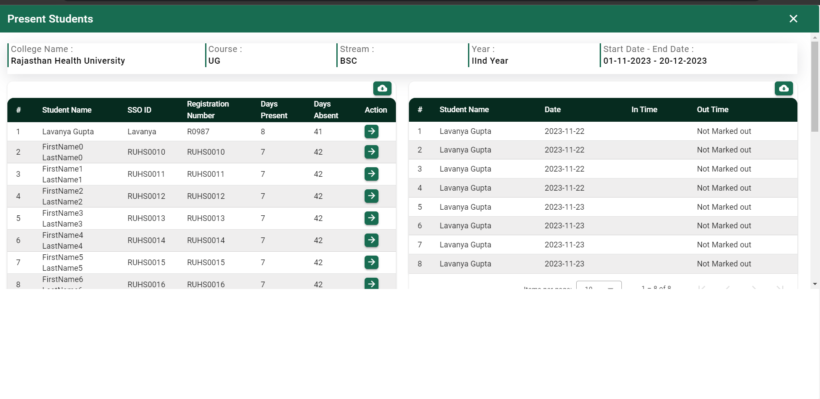

# Student

The student will have access to the holiday and his/her attendance. Students can view the current month and current session attendance on the dashboard.

* **Dashboard:** Students can view the his/her current month and current session attendance on the dashboard.

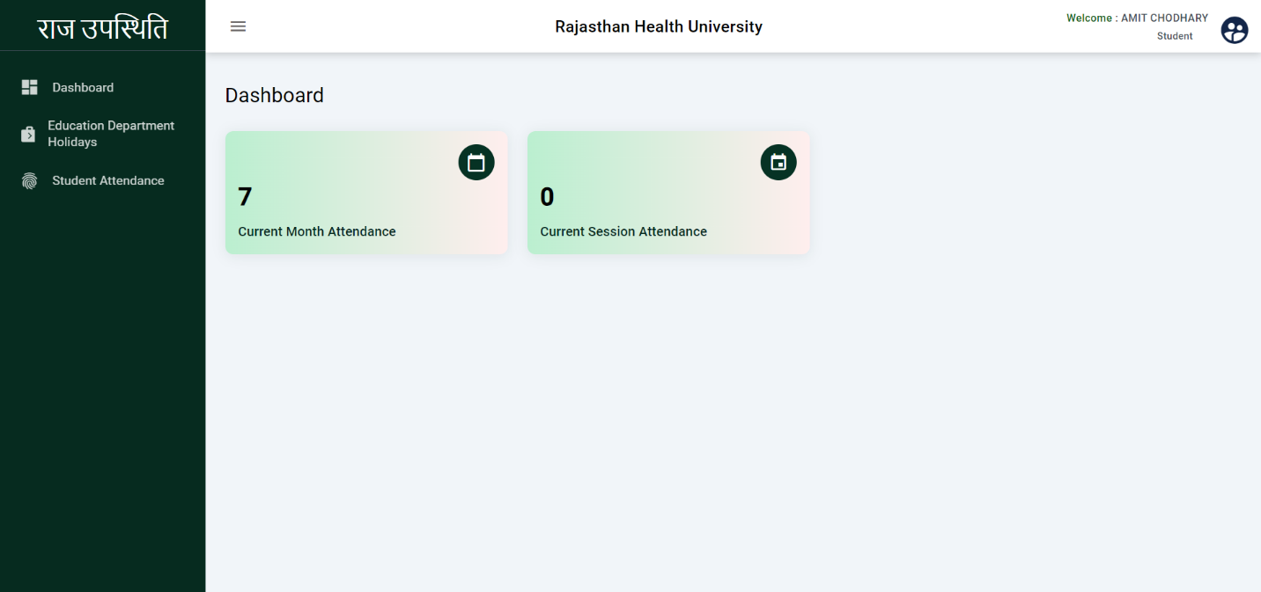

* **Education Department Holidays:** Students can view the education department holidays including Holiday Name and Holiday Date.

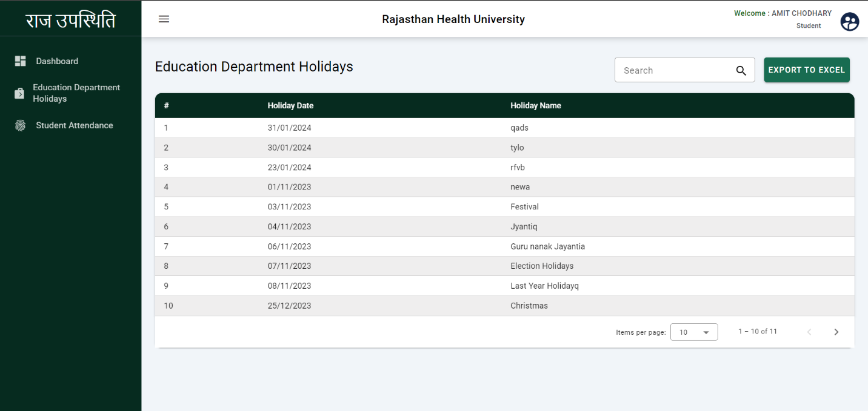

## Student Attendance Report

Students can view his/her attendance including Student Name, Date, In time, out time.

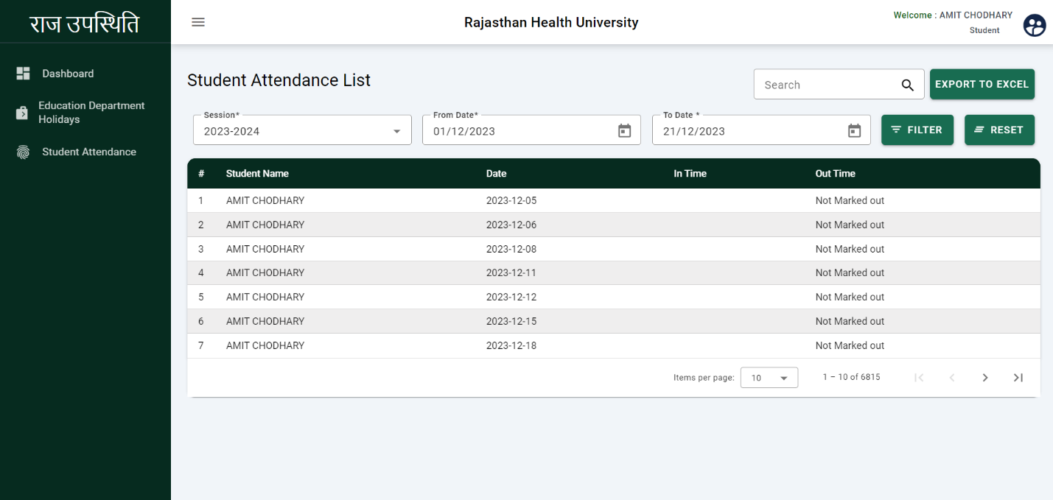

* Students can use the search filter using session, from date, and to date

**The End**